Public Disorder Offences at Riyadh Season Events
Institutional Affiliation
Students Name
Date

Introduction
Riyadh is the capital of Saudi Arabia, located in the central region of the An-Nafud desert. Riyadh is also the largest city in the Arabian Peninsula. In 2019 the city had 7.6 million people, making it the 38th most populous in Asia. Riyadh season is an entertainment season event carried out in Riyadh city in the Kingdom of Saudi Arabia. The season's events include; wide range of artistic, sporting, and cultural events, including theatre, music performances, and fashion shows. Public disorder implies considerable interventions with public peace, which results in a significant threat to the people's health and safety, including threats to public or private properties. Cyber attacks and terrorism threats are among the public disorder offenses witnessed in Riyadh province.
Terrorism Threats
Acts of terror are mainly attributed to Islamic extremists in the entire Kingdom of Saudi Arabia. Their targets included foreign civilians, mainly Westerners attracted to its oil-based economy and the Kingdom and law enforcers' citizens (Bahgat, 2004).
Figure 1; Saudi Arabia terrorism index
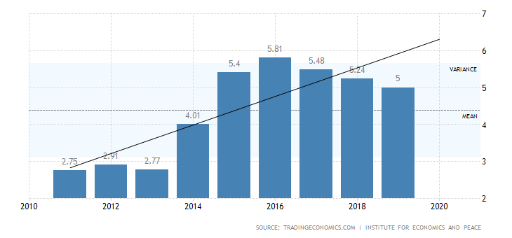
The figure above shows that terrorism indices have been very high between 2014 to 2019. The highest terrorist activities were recorded in 2016. Terrorists' attacks with little to no warning, targeting tourist locations, transportation hubs, markets/shopping malls, and local government facilities. (Saudi Arabia 2019 Crime & Safety Report: Riyadh ). ISIS and Al-Qaida in the Arabian Peninsula (AQAP) are the leading terrorist groups that demonstrate the ability to inspire individuals to conduct attacks and expand operational capabilities for planning and executing attacks inside Saudi Arabia, Riyadh city included.
Prevention, Mitigation, and Response
Prevention
To reduce the probability of terrorism from high to low, terrorism prevention should always appear as the first step in dealing with terror. Establishing a counter-terrorism strategy helps detect terror at an early stage, thus allowing for prevention and contingency planning. Modification of criminal laws and procedures by the government against terrorism within the parameters set by fairness and fundamental rights (Bahgat, 2004).
Mitigation of Terrorism
Mitigation comes second after the prevention of terrorism plan. Mitigation helps in the reduction of the socio-economic impact of terror. The major terrorist attack in Riyadh is bombing. In December 2019, Saudi security forces killed two terrorists possessing RDX explosives and materials for a car bomb in Dammam (Saudi Arabia 2020 crime and Safety Report). Mitigation of terrorism involves creating a solid security force that responds to terrific attacks quickly anywhere in the Kingdom. Conducting arrests on suspected terrorists also helps in combating terrorism (Al-Mulhim et al, 2020).
Response to terrorism
The response is the third step in planning for terrorism. The ministry of the interior should come together with the other government agencies that deal with terrorism to respond to terror in case of any quickly. Most of the explosive attacks usually result in flames; thus fire extinguishing team should be in place to react quickly to such occurrences.
Cyber Attacks
Cyber-attack refers to hackers attempting to take control, damage, or destroy the computer network or system of an organization. According to Saudi Arabia's National Cyber Security Center (NCSC) report in 2017, the government is highly affected by cyber insecurity, followed by energy and telecommunication, with percentages of 48, 15, and 11, respectively. Riyadh is the capital of Saudi Arabia and is expected to experience significant cyber threats since most government offices are located in this region. In 2012 and 2016 focused on the private sector and Saudi government agencies, spurring action from Saudi policymakers and local business leaders. The world's biggest oil company was among the firms hit by Shamoon in 2012. Powershell malware was used to conduct a cyber-attack that targeted government facilities in 2016 (NCSC report 2017).
Figure 2; percentage distribution of cyber threat targets in 2017 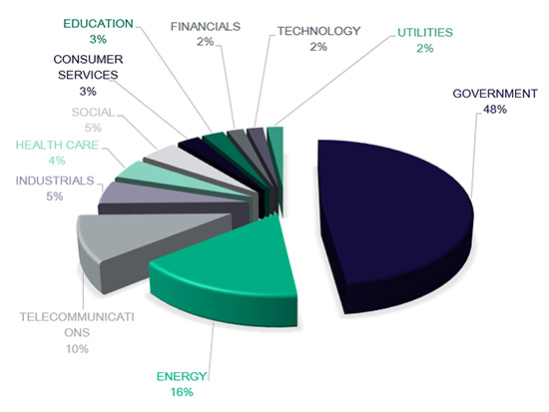
Prevention, Mitigation, and Practice
Prevention of Cyber Attacks
Cyber-attacks, including hacking, of business websites and computer systems, are increasingly common around the globe. A compliance work plan addressing cyber-attack procedures and other compliance matters should be created to monitor the risks of cyber-attacks. Review of employee policies governing access to the systems, employee policies (for example, an electronic system use policy) should restrict employees from "unauthorized access" or "exceeding authorized access" of the company's computer systems, investing in security and protection measures such as; applying the latest security patches, protecting all passwords, using read-only views of documents and materials when possible, and maintaining strict input validation (Alqurashi et al., 2020).
Mitigation of Cyber Attacks
Every company that relies on computer network systems is prone to cyber-attack, and hence they should always prepare for an attack at all times. Continuous employee education, monitoring network traffic for suspicious activity, implementing robust endpoint security, and hardening external facing web applications are guidelines for mitigating cyber-attacks (Alelyani, & Kumar, 2018).
Responses to Cyber Attacks
Coordination between the ministry of interior and internet service providers needs to be established to provide quick reactions in case of attacks—implementing strict laws for those found guilty of cyberattacks.

References
Alelyani, S., & Kumar, H. (2018). Overview of cyberattack on saudi organizations.
Al-Mulhim, R. A., Al-Zamil, L. A., & Al-Dossary, F. M. (2020). Cyber-attacks on Saudi Arabia Environment. International Journal of Computer Networks and Communications Security, 8(3), 26-31.
Alqurashi, R. K., AlZain, M. A., Soh, B., Masud, M., & Al-Amri, J. (2020). Cyber Attacks and Impacts: A Case Study in Saudi Arabia. International Journal, 9(1).
Bahgat, G. (2004). Saudi Arabia and the war on terrorism. Arab Studies Quarterly, 51-63.

